Lab Manual for Data Structure and Algorithm
(LAB-02)
(Looping structure, Arrays, Searching in arrays, Rand() function, Functions
and

structures) Lab Demonstrator: Muniba Khan

Lab 2
Contents | Logical operators with loops and switch statements, nested loops, Arrays, Searching in arrays, Declaration and initialization of array using for loop, Use of rand() function to  generate random numbers, Functions and struct, implementation of Functions, Call by value and call by reference, Struct & passing struct to a function, Built-in functions.

Topic: Use of rand() Function, Functions, Structs, and Built-in Functions Objective
The purpose of this lab is to understand the concepts of:
- Generating random numbers using the rand() function.

- Implementing functions in C++.
- Understanding Call by Value and Call by Reference.

- Working with structures (struct) and passing them to functions.

- Using built-in library functions like sqrt().

1. Introduction
Control structures define the logical flow of execution in a program.
Types of control structures in C++ are as follow:
- Selection Statements: Used for decision-making (if, if–else, switch).
- Repetition Statements: Used for looping (for, while, do–while).

- rand() Function

The rand() function is used to generate pseudo-random numbers. It is defined in the <cstdlib> (or <stdlib.h>) library.
  - Syntax: int n = rand();

  - To limit the range: n = rand() % 100; // generates numbers between 0–99
  - For more randomness, use srand(time(0)); to seed the generator.

- Functions in C++

A function is a block of reusable code that performs a specific task. Functions help in code modularity, readability, and reusability.

Types of Functions:

  - Void functions: Don’t return a value.
  - Value-returning functions: Return a value to the caller

int add(int a, int b) { return a + b;
}
- Call by Value and Call by Reference

  - Call by Value: A copy of the actual parameter is passed; changes do not affect the original variable.
  - Call by Reference: The address (reference) is passed; changes affect the original variable.
- void updateByValue(int x) { x = 10; }

- void updateByRef(int &x) { x = 10; }
- Structures (struct)
A structure is a user-defined data type that groups related variables.
struct Student { string name; int age;
float gpa;
};
- Built-in Functions
These are predefined library functions in C++, such as:

  - sqrt() – square root

  - pow() – power function
  - toupper(), tolower() – character case conversion

  - rand(), abs(), etc.

Lab Tasks
- Write a program to declare an integer array of size 100 and initialize it with random values between 0-99 inclusive. Output the array in following format to see if correct values are assigned.
Sample output 1:
array[0] = 23
array[1] = 34
array[2] = 87
:
array[99] = 75

Hints:
- Use for loop to initialize array and rand() function to generate random numbers.
- Use % operator to limit the generated number between 0 and 99.
Solution:

#include<iostream> #include<stdlib.h> using namespace std;
int main()
{
int array[100];
for(int i =0; i<100; i++)
{
array[i] = rand() % 99;
}

for(int i =0; i<100; i++)
{
cout << "array["<<i<<"] = "<<array[i] << endl;
}
}

Output
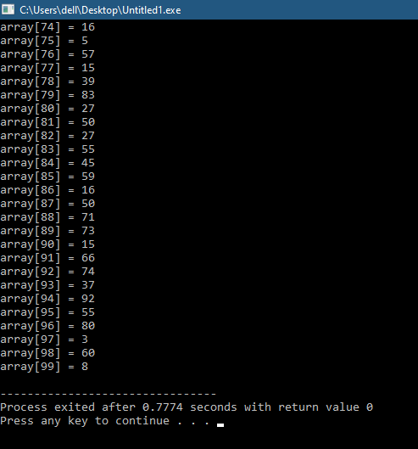

- Write a value-returning function, isVowel, that returns the value true if a given character is a vowel and otherwise returns false. Function should be able to handle both upper and lowercase characters. Write main function to test the isVowel funciton.
Sample output 1:
Please enter a character a
Character a is a vowel character
Sample output 2:
Please enter a character M
Character M is not a vowel character
Solution:
#include
<iostream> using namespace std; boolisVowel(char letter);
int main()
{
char userChar;

cout << "Please enter a character:
"; cin >> userChar;

if (isVowel(userChar))
cout << "Character "<< userChar << " is a vowel" << endl; else cout << "Character "<< userChar << " is not a vowel" << endl;

return 0;
}

bool isVowel(char letter)
{ switch (letter) { case 'a':
case 'e':
case 'i':
case 'o':
case 'u':
case 'A':

case 'E':
case 'I':
case 'O':
case 'U':
return true;
default:
return false;
}
}

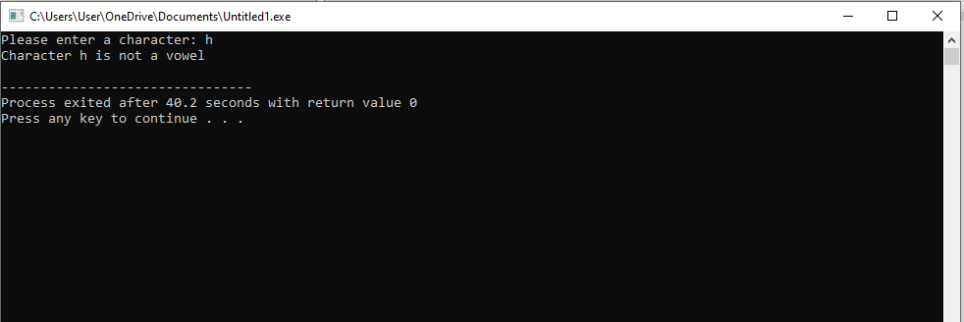
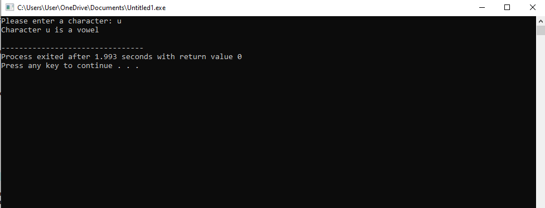
Output

- Write a program that finds the square root of a number using built-in function fsqrt()? (Hint: math.h, sqrt()).
Solution:

#include<iostream> #include<math.h>
using namespace std; int main()
{
int x; float sq; cout<<"Enter a value
you want to take
square root of";
cin>>x; sq=sqrt(x);
cout<<"Thesquare root of "<< x
<<" is "<<sq;
}
Output
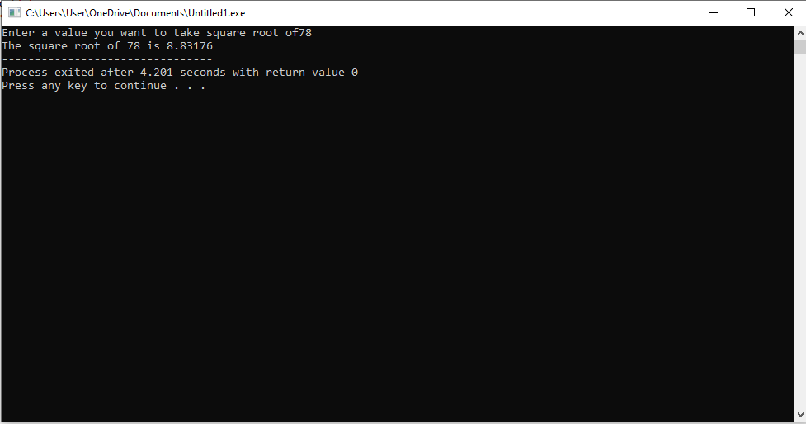

- Write a program that finds the square root of a number using built-in function fsqrt()? (Hint: math.h, sqrt()).

Solution: #include<iostream> #include<math.h> using namespace std; int main()
{
int x; float sq; cout<<"Enter a value you want to take square root of"; cin>>x;
sq=sqrt(x); cout<<"The square root of "<< x
<<" is "<<sq;
}
Output

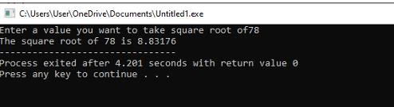

Home Lab Assignment
Q1. Write a program to generate 10 random numbers between 1 and 100 using the rand() function and display them.
Q4. Write a program using a structure Student with fields name, rollNo, and marks. Input data for 3 students and display all records.
Q5. Write a program that reads a number and displays results using built-in math functions: sqrt(), pow(), abs(), ceil(), and floor().
Q#6 Switch Case -Write a program that acts as a Smart Temperature Advisory System.
The user enters the current temperature (°C) and selects a weather condition (1 for Sunny, 2 for Rainy, 3 for Cloudy).
Based on the inputs, display suitable advice:
- If it’s sunny and above 35°C → “Too hot, stay indoors!”
- If it’s rainy → “Carry an umbrella!”
If it’s cloudy and below 15°C → “Cold and cloudy, wear warm clothes.”
Handle invalid weather condition inputs gracefully
Q8. Write a program to check whether a given character is a vowel or not using a function.
Q9. Write a program to calculate the factorial of a number using a function.
Note: Deadline for Lab Assignment is Sunday, 26 October 2025 till 10 pm

